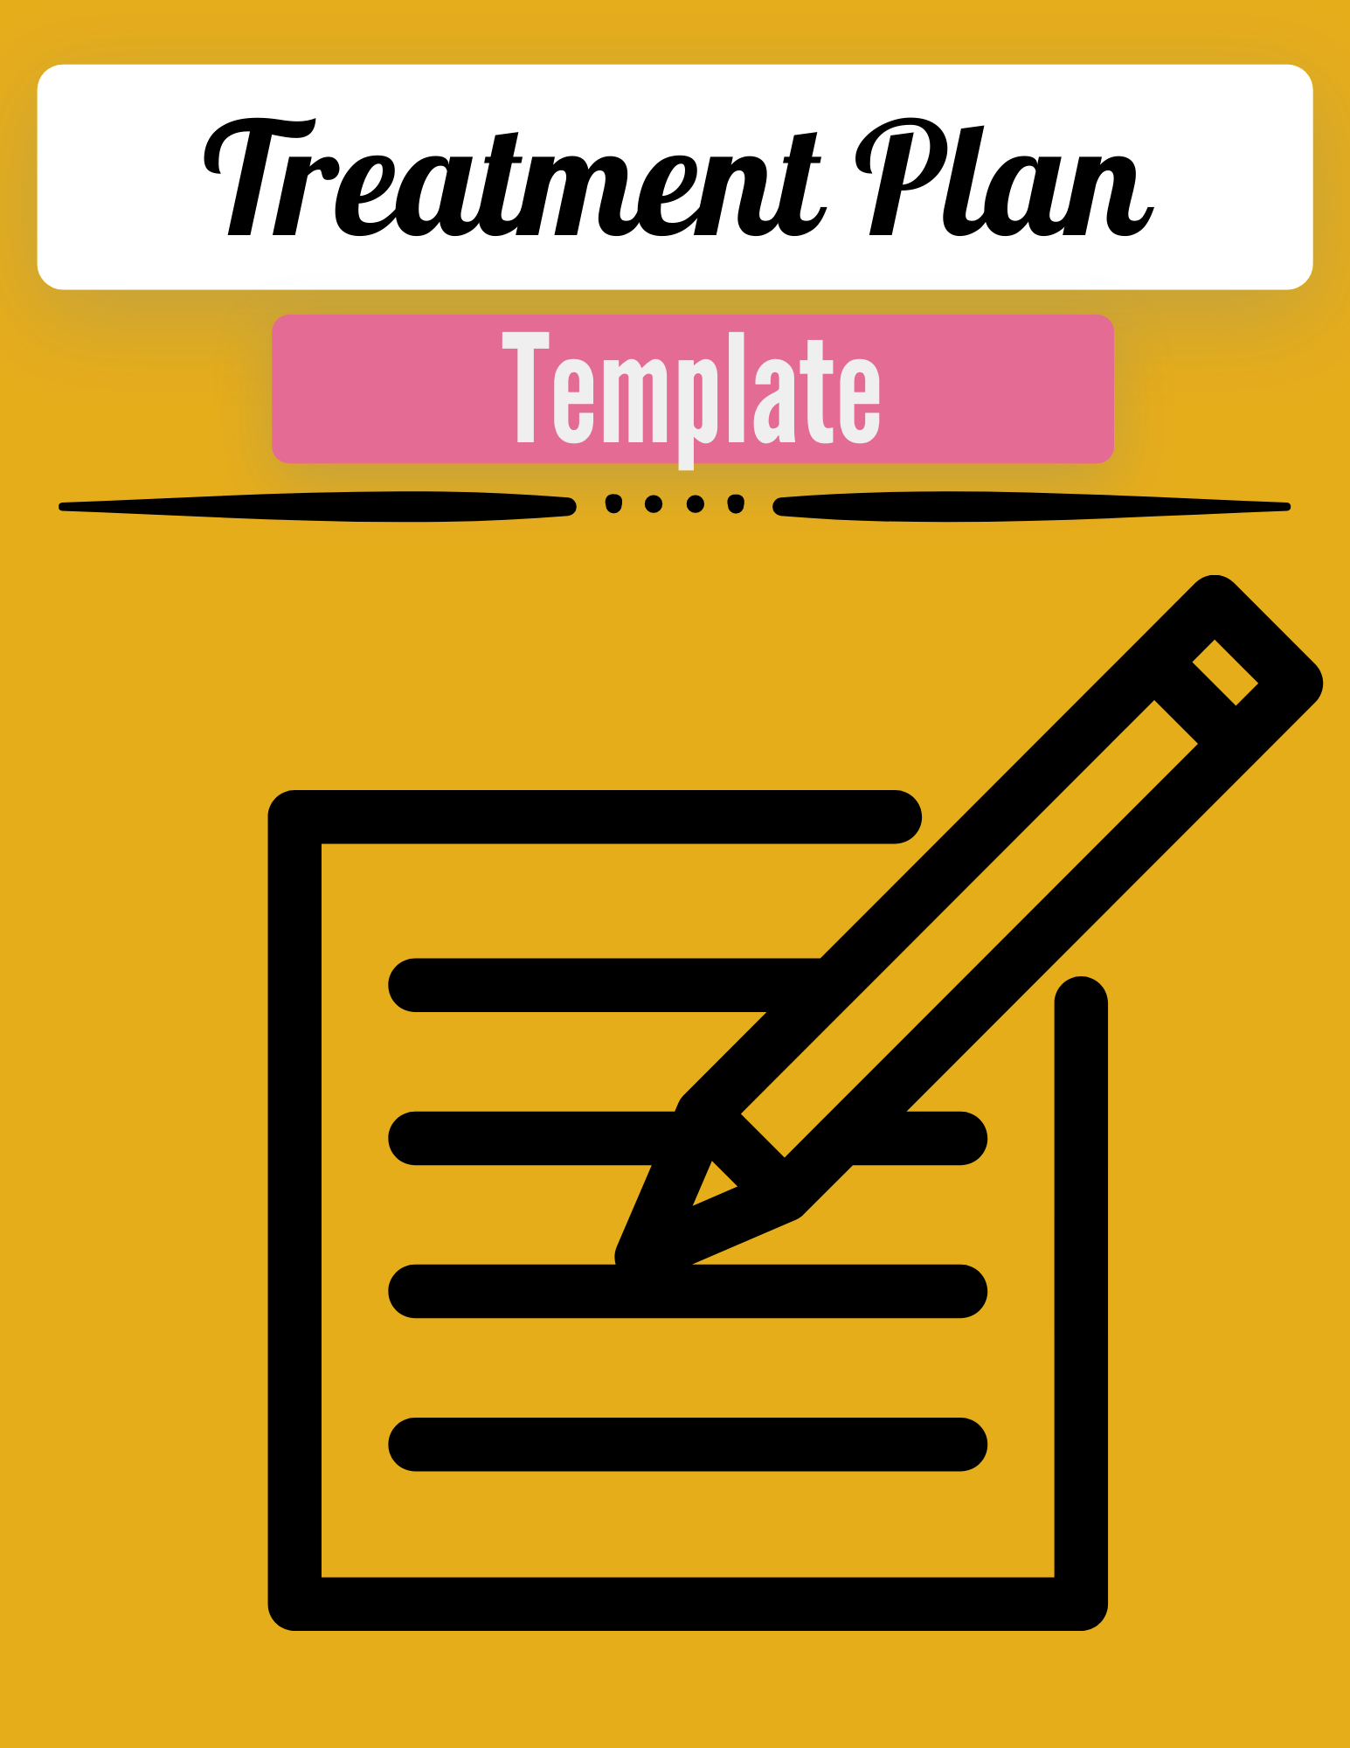

Treatment Plan Template:

Reference Video: https://youtu.be/6uWy7n6q9h0

Long-Term Goal

**** (client identified: elicited during intake)

Treatment Goal: Decrease *** (overarching issue/theme/complaint: anxiety)

Short-Term Objectives:

- Increase *** (desired attribute: eg. distress tolerance) as seen by decreasing *** (target behavior: eg. arguments with) *** from (baseline: eg. 1x/week) to (desired goal: eg 1x/month) for 90 consecutive days (****important to have sustained duration) and decrease (target behavior: eg avoidance bx) …

- Lower baseline PHQ-9 and GAD-7 scores by at least three points.

Clinical Interventions:

Eg. Provide individual CBT for addressing depression and anxiety through implementation of therapeutic techniques (mood tracking, thought stopping, deep breathing/mindfulness/grounding, thought challenging/reframing, habituation and interpersonal effectiveness/communication skills).

Client commitment:

Client will attend scheduled appointments and will call to cancel and reschedule if not able to attend.

Client will complete assignments and be prepared to discuss findings in session.

